ABC
Automated Cloud
Provisioning Portal
USER & DEVELOPER GUIDE
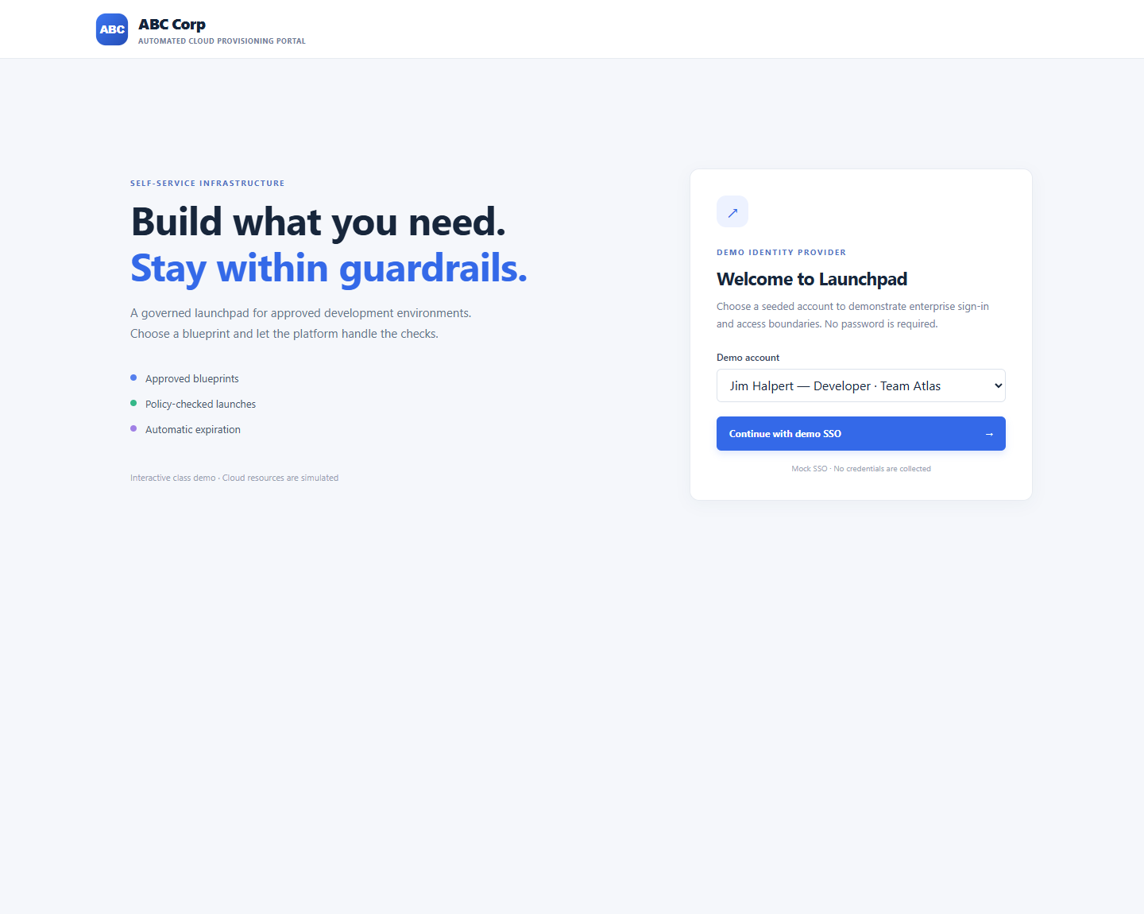
Application screenshot 1. Passwordless demo sign-in and seeded personas.

How to use this guide
Use Part I to run and demonstrate the portal as an end user. Use Part II to understand the implementation, map the five detailed stories to source behavior, and safely extend the sample. The screenshots are captured from the runnable application; names and resource entries are seeded demo data.
Part | Audience | What it covers
I. End-user guide | Developers, managers, Security Administrator | Starting the app, switching personas, browsing blueprints, requesting environments, reading policy results, cost/TTL, resource inventory, manager/team views and policy administration.
II. Developer guide | Developers, Testers and Support | Project layout, architecture, persisted data, story-by-story implementation, current scope gaps, security boundaries, manual verification and troubleshooting.

Quick reference
Task | How
Start the portal | Windows: double-click run-demo.bat in the application folder. Python 3 is required.
Open the app | http://localhost:8000 (the launcher binds to 127.0.0.1 on this computer only).
Stop the app | Return to the command window and press Ctrl+C.
Reset browser demo data | Sign in and click Reset demo data; confirm the prompt. This clears saved environments, policies and selected persona in that browser.
Select a persona | Use the Demo account dropdown and Continue with demo SSO; no password is used.

Part I : End-user guide

1. Start the demo
- Install Python 3 if it is not already available on the Windows computer.
- Open the Automated Cloud Provisioning Portal Demo folder and double-click run-demo.bat. A command window launches a small local web server and opens the portal.
- If the browser does not open, navigate to http://localhost:8000. Leave the command window open during the demonstration.
- To stop the server, focus its command window and press Ctrl+C.
Alternative PowerShell command (run from the demo folder):
py -m http.server 8000 --bind 127.0.0.1
NO CLOUD REQUIRED No cloud credentials, external packages, or cloud account are needed. Do not treat displayed resources as real or billable infrastructure.

2. Sign in and understand access
Choose a seeded persona from the Demo Identity Provider selector and press Continue with demo SSO. The header displays the signed-in person, role, and team. Switch user returns to the login screen so another persona can be selected.
Application screenshot 2. Choose a persona; no password is collected.
Persona | Role / team | What they can demonstrate
Jim Halpert | Developer : Team Atlas | Browse catalog, submit requests and see Team Atlas environments.
Oscar Martinez | Developer : Team Atlas | Second developer account for shared Team Atlas visibility.
Michael Scott | Manager : Team Atlas | Read-only view of Team Atlas requests and TTL manager persona.
Pam Beesly | Developer : Team Nova | Submit requests and see Team Nova environments.
Andy Bernard | Manager : Team Nova | Read-only view of Team Nova requests.
Dwight Schrute | Security Administrator : Enterprise Security | Cross-team request view and security/compliance policy administration.

ACCESS RULE Developers can create requests and see only their own team. Managers have a read-only request view limited to their assigned team. The Security Administrator can see requests across teams and manage policies.

3. Browse the approved service catalog (US-01)
- After developer sign-in, review the three catalog cards: Node.js API Service, Python Microservice, and Kubernetes Namespace.
- Click a card. Its selection highlight changes and the Selected blueprint field in the request form updates.
- Review the card metadata before configuring the request. The catalog is seeded demo metadata; the cards do not point to deployable IaC modules.
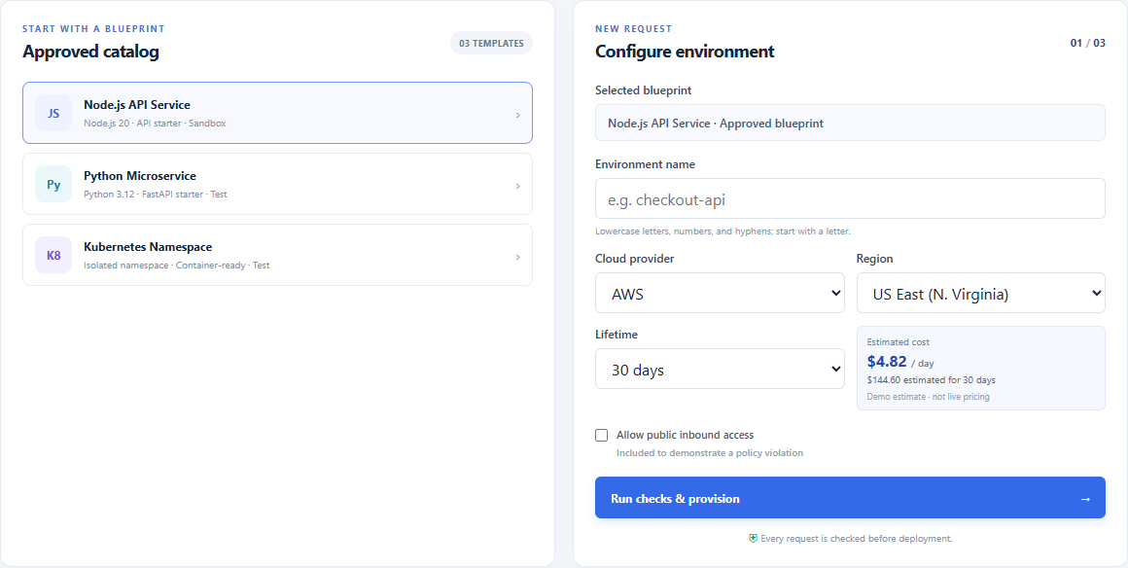
Application screenshot 3. Catalog cards and synchronized selected-blueprint/request panel.

4. Configure a request and review cost (US-02 / US-05)
- Enter a unique demo name using lowercase letters, digits and hyphens; it must begin with a lowercase letter. Example: checkout-api. Invalid names are blocked by the preflight check when submitted.
- Choose AWS, Azure, or GCP. The Region selector changes to the chosen provider?s demo regions.
- Choose a lifetime of 30, 60, or 90 days. The estimate card updates to show the illustrative daily rate and estimated total for that duration.
- Review the estimate before submitting. Rates are fixed classroom sample values, not quotes from a cloud provider; actual cost depends on region, utilization, service configuration, and current provider pricing.
Application screenshot 4. Configure blueprint, environment name, provider, region and lifetime before requesting.
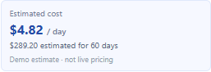
Application screenshot 5. The estimate card reflects the selected lifetime; this captured example uses the Node.js template and 60 days.
AWS blueprint example | Illustrative daily estimate | 30-day total example
Node.js API Service | $4.82 | $144.60
Python Microservice | $8.64 | $259.20
Kubernetes Namespace | $12.48 | $374.40

5. Run checks and submit (US-02 / US-06)
Press Run checks & provision. The demo validates the selected approved template, environment naming, provider-specific region, lifetime, and the public-inbound-access policy. The request outcome appears in the policy banner and request history.
Application screenshot 6. A compliant request displays a green policy-check result.

Demonstrate a blocked request
- In the request form, enter a valid demo name and select Allow public inbound access.
- Press Run checks & provision. The demo records the request as Blocked and explains that the active public ingress policy prevents it. A blocked request has no simulated resources.
Application screenshot 7. A request violating the enabled ingress policy is blocked before simulated provisioning.

6. Read environment status and inspect resources
The environment table lists the environment, provider/template/region, status and expiration, owner/team, TTL and daily estimate. A valid submission is shown as Provisioning briefly, then changes to Provisioned. Expand View resources to inspect the simulated inventory.
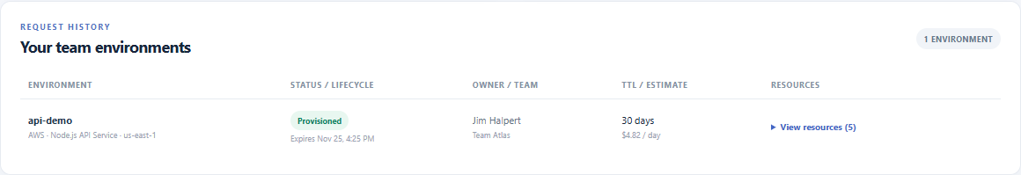
Application screenshot 8. Environment history with status, owner, TTL, estimate and resource disclosure.
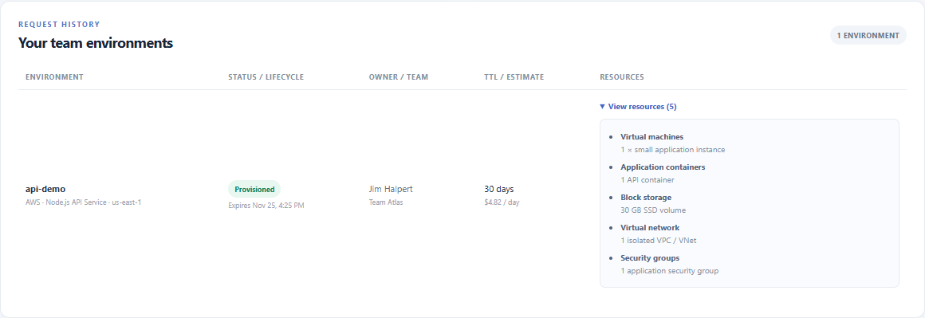
Application screenshot 9. Expanded example inventory: instance, container, SSD, network and security group.

7. Compare manager team views
Switch user to Michael Scott to see Team Atlas requests, or Andy Bernard to see Team Nova requests. Managers cannot create requests. Each manager?s environment list is filtered to the manager?s own team; Dwight Schrute retains the cross-team administrative view.
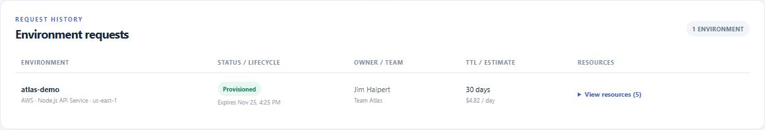
Application screenshot 10. Michael Scott?s read-only Team Atlas request history; Team Nova requests are excluded.

8. Manage security and compliance policies
Sign in as Dwight Schrute. The Security & compliance policies section is displayed only to the Security Administrator. The screen presents seeded policy records, their category and state, and controls to edit, enable/disable, or add policies. Changes persist in this browser?s local storage.
- To add: fill Policy name, Category, and Description, then choose Add policy. New policies are enabled by default.
- To edit: choose Edit on a policy, update the form, and choose Save changes. Choose Cancel edit to discard the form changes.
- To enable or disable a policy: use the policy?s On/Off checkbox. The public inbound access policy is connected to the provisioning preflight. Other policy records are demonstration metadata and are not independently evaluated by the deployment check.
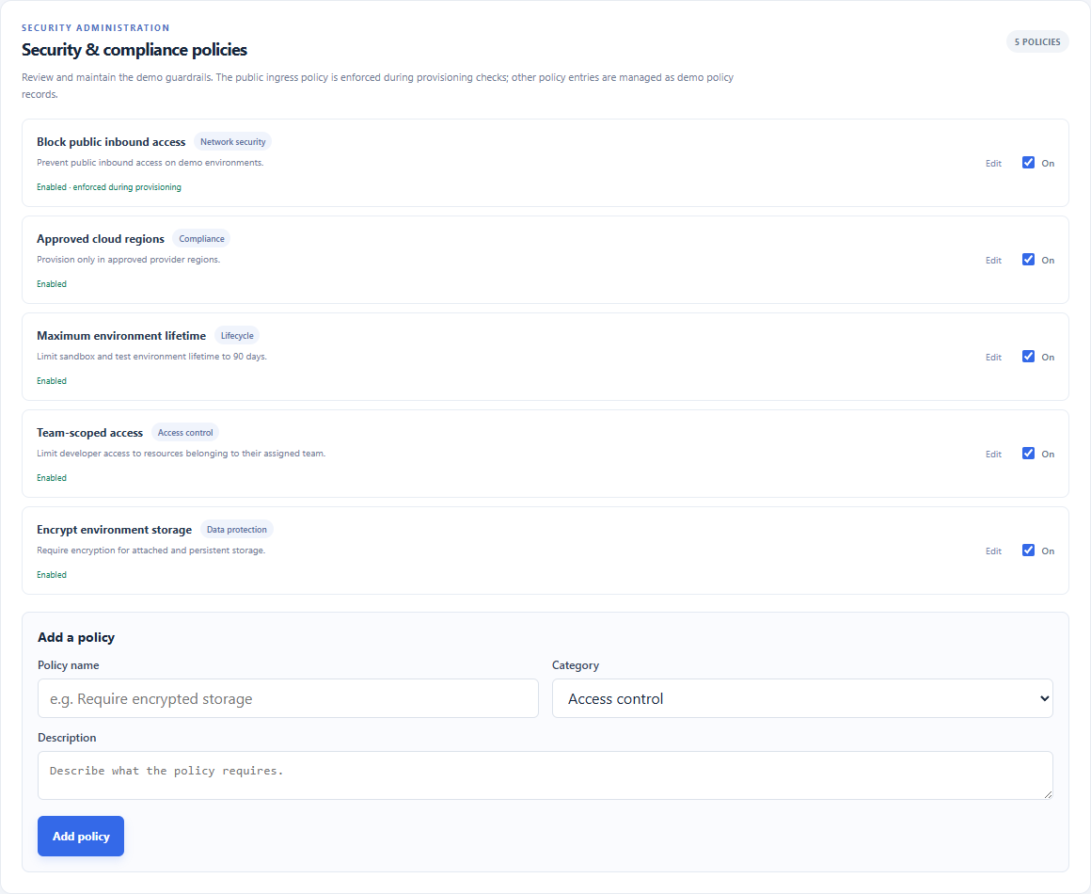
Application screenshot 11. Security Administrator policy list and add-policy form.

9. Troubleshooting for end users
Symptom | Try this
The browser cannot open localhost:8000 | Confirm the launcher command window is still running. If the port is occupied, stop the other local server or use a different port and update the browser URL.
The login selection appears to have no effect | Choose an account from the list, then press Continue with demo SSO. No password is required.
A request is blocked | Read the red banner for the first policy/validation reason. For the demo policy example, uncheck public inbound access and submit again.
Old requests or policies are visible | Use Reset demo data to restore the initial state for this browser origin. Reset requires confirmation.
A manager sees no environments | That manager sees only their own team. Switch to a developer assigned to the matching team to create an example request.

Part II : Developer guide

10. Project layout and local execution
Path | Purpose
Automated Cloud Provisioning Portal Demo/index.html | Single-page UI structure, form fields, status areas, catalog, environment table and Security Administrator policy panel.
Automated Cloud Provisioning Portal Demo/styles.css | Responsive layout, colors, buttons, tables, policy cards and responsive behavior.
Automated Cloud Provisioning Portal Demo/app.js | Seed data, local-state persistence, UI rendering, access scoping, input checks, policy simulation, estimates and lifecycle simulation.
Automated Cloud Provisioning Portal Demo/run-demo.py | Python standard-library HTTP server; serves only on 127.0.0.1:8000 and opens the browser.
Automated Cloud Provisioning Portal Demo/run-demo.bat | Windows entry point. Uses py or python to run run-demo.py.
Automated Cloud Provisioning Portal Demo/architecture.drawio | Editable diagrams.net architecture covering all 12 proposal stories; top five highlighted.
Docs/5 detailed user stories.docx | Source detailed story narratives, UI mapping and acceptance criteria used for this guide.

Run locally
Windows: double-click run-demo.bat
PowerShell alternative (from the demo folder):
py -m http.server 8000 --bind 127.0.0.1
The project has no application package manifest or external runtime dependencies. The PowerShell command serves static files; the Windows batch launcher invokes the included run-demo.py wrapper. Neither command provisions cloud resources.

High-level request flow
Step | Current implementation
Persona selection | The login selector chooses a seeded identity; currentUserId is saved in local storage.
Catalog and configuration | The client renders the three catalog records, provider-specific region choices, TTL options and a hard-coded estimate.
Preflight | runPolicyChecks validates role, template, name syntax, provider/region pair, TTL range and the enabled public-ingress policy.
Request record | A blocked request is stored with blocked status and no resources. A passing request is stored as provisioning with an illustrative inventory.
Completion | A browser timeout of about 950 ms marks a passing record Provisioned. This is a UI simulation, not an infrastructure job.
Lifecycle | Expiration and warning states are derived from expiration timestamps when render/lifecycle reconciliation runs; records are updated in browser storage.

11. Data and component model
This is a static client-side sample. There is no backend API, database, authorization service, cloud adapter, or infrastructure-as-code runner. The browser stores a JSON object in localStorage under abc-cloud-launchpad-demo-v1. Storage is per browser profile and site origin.
State field | Contents / behavior
currentUserId | Seeded persona identifier (ava, ron, casey, noah, andy, sam).
selectedTemplateId / selectedProviderId | Current catalog selection and AWS/Azure/GCP selector preference.
environments | Request records: name, template, provider, region, owner/team, created/expiration timestamps, TTL, estimate, status, policy reasons, and simulated resources.
policies | Default and custom policy records with id, name, category, description, enabled state. The public ingress policy is wired into the check.
clockOffsetMs | Legacy demo-clock state retained by the sample state model. There is no clock-advance button in the current UI.

Validation and rendering
- The policy validator accepts names matching lowercase a-z at the start, then lowercase letters, digits, or hyphens; total length is 2?32 characters. The browser form has required and max-length controls, while format validation is performed during submission rather than live as the user types.
- Provider region values are constrained to the selected provider?s seeded region list. A changed provider resets the selected region if it is not available for the new provider.
- Lifetimes are exactly 30, 60, and 90 days. The template maximum is currently 90 days.
- Dynamic values inserted into HTML templates use escapeHTML before rendering; continue escaping all user-controlled text added to innerHTML.
- Policy changes and requests are saved locally; loadState filters and normalizes persisted record shapes. Storage failures are logged and surfaced as a notice.

12. Detailed user-story implementation mapping

US-04 : Role-Based Access Control & Enterprise SSO Gateway (Priority 1)
Source intent: authenticate a Security Administrator or Developer through enterprise SSO using seeded personas, then scope view/deploy/manage actions to team and privilege boundaries. The story?s named examples include Jim Halpert and Oscar Martinez.
- UI mapping: Demo Identity Provider dropdown, Continue with demo SSO, persistent user/role/team badge, and Switch user action.
- Demo implementation: the selector is mock SSO with no password. Developer personas are Jim Halpert and Oscar Martinez (Team Atlas), Pam Beesly (Team Nova). Managers are Michael Scott (Atlas) and Andy Bernard (Nova); Dwight Schrute is the Security Administrator.
- Authorization: only the Developer role can submit provisioning requests. Developers and Managers see environments where environment.team equals their user.team. Security Administrators can see all team records and policy controls.
- Check: select each persona, confirm the header, confirm team scoping, and switch persona back to login.

US-01 : Service Catalog Browsing & Blueprint Selection (Priority 2)
Source intent: browse standardized, approved Infrastructure-as-Code blueprint choices and select a preconfigured architecture.
- UI mapping: Approved catalog with Node.js API Service (Node.js 20), Python Microservice (Python 3.12 / FastAPI), and Kubernetes Namespace cards.
- Behavior: selecting a card highlights it and synchronizes the Selected blueprint label in the request form.
- Check: verify exactly three cards, distinct names/metadata, and selection synchronization.

US-02 : Single-Click Automated Environment Provisioning (Priority 3)
Source intent: configure an environment name and deployment parameters, then request automated deployment without a manual ticket.
- UI mapping: environment name, cloud provider, provider-specific region, TTL, estimated cost, public ingress demonstration toggle, and Run checks & provision action.
- Providers: the current implementation offers AWS, Azure, and GCP. The detailed story file refers to Azure and ?ACP? as the alternatives to AWS; GCP is what the built demo currently offers.
- Behavior: a successful preflight adds a Provisioning row, then a short timer changes it to Provisioned. A failing request adds a Blocked row with an explanation and no resource inventory.
- Check: submit valid and invalid names; verify provider-region synchronization; verify team-specific history and the status transition.

US-06 : Automated Compliance & Security Policy Scanning (Priority 4)
Source intent: run policy-as-code checks before execution and block unsafe templates/configurations.
- Current checks: Developer role, approved catalog item, lowercase name syntax, provider/region membership, 1?90-day TTL, and public ingress when the built-in policy is enabled.
- Pass/fail UI: green confirmation banner for a passing preflight; red blocked banner with reason for a failure. Blocked requests are retained in request history but do not get simulated resources.
- Policy editor relationship: toggling Block public inbound access changes that check. Other policy cards are editable records only and are not automatically enforced by runPolicyChecks.
- Check: submit a compliant request; then submit with public inbound access enabled; confirm the respective banner and record outcomes.

US-05 : Resource Lifetime Management (TTL) & Cost Governance (Priority 5)
Source intent: enforce default lifetimes, show costs, warn as expiration approaches, and decommission temporary resources to prevent waste.
- TTL choices: 30, 60, or 90 days, with 30 days selected by default. Expiration is computed from the request timestamp plus the selected lifetime.
- Estimate: provider/template-based illustrative daily rate and daily rate multiplied by selected days. AWS source examples: Node.js $4.82/day, Python $8.64/day, Kubernetes $12.48/day. Azure and GCP use separate hard-coded demonstration rates in app.js.
- Environment inventory: expand View resources for the template?s simulated instance/pods/container, storage, network, and security-group breakdown.
- Lifecycle: rows show Provisioned, Expiring soon within 24 hours, or Decommissioned. Reconciliation is triggered on app render (including sign-in/reload); it is not a background timer. There is no Advance demo clock control in the current application.
- Check: select 30/60/90 and verify the estimate; inspect stored expiration timestamp display. For an automated expiry test, use isolated test data with an expiration timestamp in the past, then reload/sign in and verify the status is reconciled.

13. Manual verification checklist
Check | Expected demo result
Sign in and switch identity | Selected persona is shown in header; Switch user returns to login.
Team scope | Michael sees only Team Atlas, Andy sees only Team Nova; Dwight sees both.
Catalog | Exactly three cards; selected card and configured blueprint agree.
Provider and region | AWS/Azure/GCP choices populate valid regions for the selected provider.
Name validation | A valid lowercase name passes; uppercase, invalid punctuation, or leading digit is blocked after submit.
TTL and cost | 30/60/90 are selectable; estimate and total update based on blueprint/provider/days.
Policy scan | Compliant request receives green pass; public ingress request is blocked when that policy is enabled.
Resource disclosure | A successful request has a matching simulated inventory; a blocked request has no resources.
Admin policy controls | Only Dwight sees section; can add/edit/toggle; changes persist after reload in same browser.
Lifecycle | Expiration/status is reconciled on render after actual expiry; no actual cloud teardown is performed.

14. Known demo limitations and safe extension points
- Do not enter real secrets, cloud credentials, customer data, or sensitive company information. Browser localStorage is not a secure data store.
- Do not present the portal as connected to ABC Corp identity, billing, cloud accounts, secret vault, compliance tooling, or real cloud provisioning.
- For a production architecture, introduce an authenticated backend/API, server-side authorization, persistent database, cloud-specific adapters, policy-as-code engine, auditable event store, real cost source, scheduler/worker, and secure secret vault integration.
- Keep the sample?s front-end behavior consistent: provider list, cost data, catalog, validation, environment rendering, and docs should all be updated together when extending the demo.
- The editable all-story architecture is Automated Cloud Provisioning Portal Demo/architecture.drawio. It shows future backlog features as target architecture; only the prioritized five are represented by working demo flows.

15. Source references
Primary requirements: Docs/5 detailed user stories.docx (US-04, US-01, US-02, US-06, US-05; narratives, personas, UI mapping and acceptance criteria). Application behavior and implementation notes were checked against app.js, index.html, styles.css, run-demo.py, run-demo.bat, and README.md in Automated Cloud Provisioning Portal Demo.
Screenshots were captured from the running local demo with seeded sample requests. They illustrate UI behavior and do not represent live cloud resources or billing.

